# Introduction

Hotel industry can be defined as part of service industry which deals with guest housing or lodging. When we say hotel industry, it doesn’t refer to hotels only, there are different forms of overnight accommodation which comes under it, like motels, guest houses, inns. (*Hotel Industry; Everything You Need to Know About Hotels!* 2020) Hotel industry is one of the fastest growing and more earning industry in the world which contribute great sum of revenue to world economy. In the year 2017, 2018 and 2019, the total revenue in hospital industry was US$343,924m, US$355,306m and US$368,359m respectively. The revenue in the hotel segment is increasing every year but the revenue is decreased in the year 2020. The revenue for the year 2020 amounts to US$210,915 which is due to impact of COVID-19. By the year 2023, the annual growth rate of revenue is expected to be 23.0% resulting in an amount of US$392,391m. In the year 2020, the penetration rate id 8.5% which is expected to increase to 14.7% by the year 2023. In 2020 the average revenue per year (ARPU) amounts to US$334.65 in the hotel industry. The hotel industry contributes in every country economy. The revenue in United States in the year 2020 is US$51,282m which is the most generated revenue comparing globally.

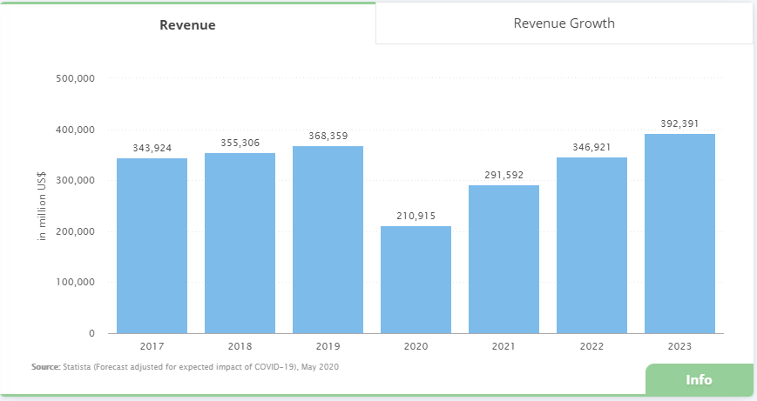

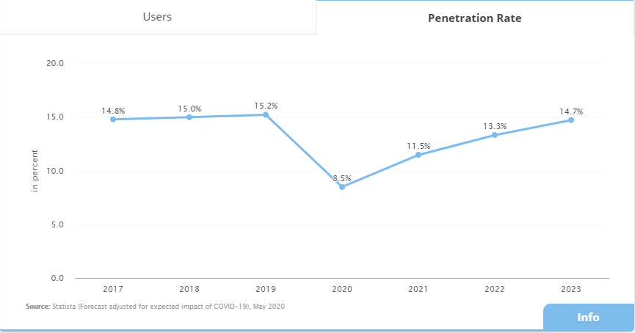

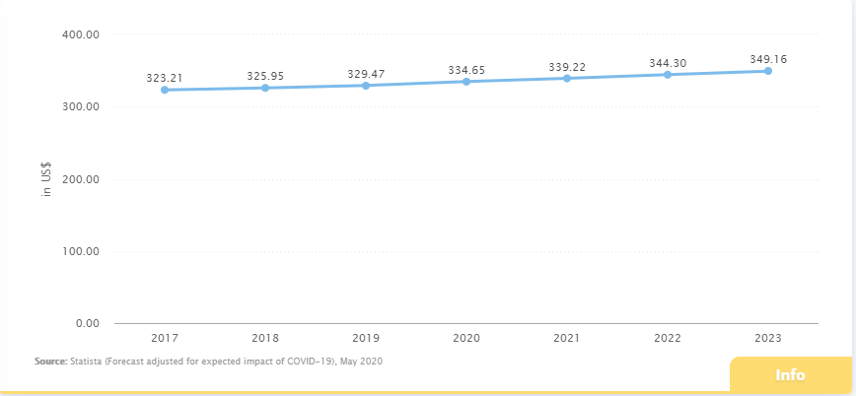

Traditionally, there were not any online booking facility and hotel rooms were sold from the counter. Some hotels could be booked by calling through phone but in most of the hotel, the guest would seek the hotel, go there and make a booking. The guest could not know if room is vacant or not, its condition, price and other details before. It creates problems for the guest, more time and effort were needed. The business was not growing much bigger and more profit could not be made. The problem was solved as this industry started using internet for running business. The use of internet and world wide web have increased all over the world now. People use internet to get information about different topic, communication purpose, entertainment purpose, setting up business relationships. Internet and technologies are playing great role for running business and their growth as it helps to perform many business processes easily like marketing, communication and advertising. It is very important to be able to access and transfer information fast and easily for business to survive in this competing world. Hotel industry is using internet for running its business processes like sharing information, communication, booking rooms and now, hotel industry is one of the growing business in the world and is progressing rapidly by using e-commerce and more recently m-commerce.

The market for online hotel booking is increasing every year. It is expected that 76% of total revenue will be produced through online booking in hotel field by the year 2023. In the year 2018, there was increase in hotel and accommodation searches on search engines by 23% than the year 2017. 31% of hotel and accommodation searches was done. In 2018, 82% of all travel bookings were done online by using website or mobile application. The average online conversion rate of hotels is 2.2%. Customer can make online hotel booking by using hotel owned website or mobile application and through Online Travel Agents (OTAs). Online Travel Agents is defined as a distribution channel which is established for selling travel related products to customers. Hotels, travel packages, fights come under these products. Online Travel Agents serves as marketing as well as distribution channels for hotel. Most of the people use OTA for online hotel booking because customer can search for hotel easily, read reviews, compare prices and they can book, view other travel related products also from same website. Some of the famous Online Travel Agents are Booking.com, Expedia, TripAdvisor. In July 2019 there were 697 million and 224 million visits to Booking.com and TripAdvisor website respectively.

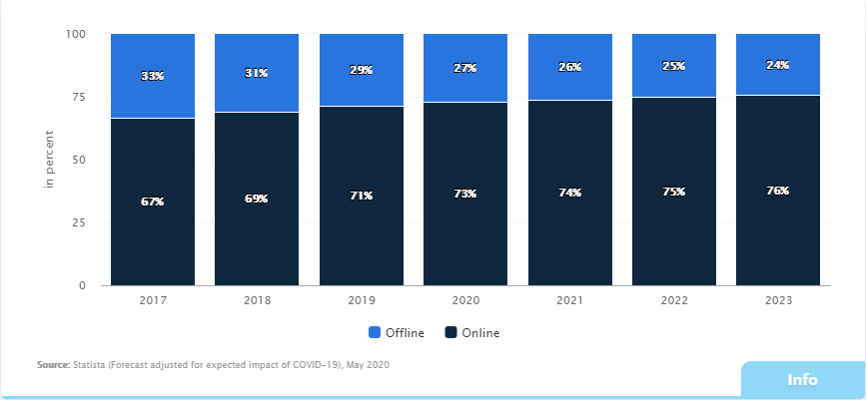

The motive of this paper is to build a dashboard of visual analytics which demonstrates how customer make decision while booking hotel from online. The hotel industry is growing bigger and bigger and online hotel booking rate is also increasing. With these things, competition is also increasing. So, investing in business, opening hotels and running it is not sufficient now. For surviving in business and making profit, we must have knowledge about how a customer behaves, think while booking online. The thorough research about the customer of business, their needs and how they respond is must. Customer perform certain research and gather as much information while booking the hotel. They compare the price of hotel in different websites. Customer look picture of rooms of hotels, they look for the facilities provided. Different customer has different strategy, idea for choosing the hotel. Different information from different internet sources like good and bad side of hotel, review and ratings, photos and videos by other customers, recommendation from website might brainwash the customer mind which effects in decision making process. In this paper, the factors affecting customer hotel booking decision will be discussed in detail.

# Factors influencing booking decision

There are different factors that influences a customer while making decision. In 2016, TripAdvisor (one of the popular Online Travel Agent) conducted a study among 34,026 participants and list out the top 10 influencing factor for decision making.

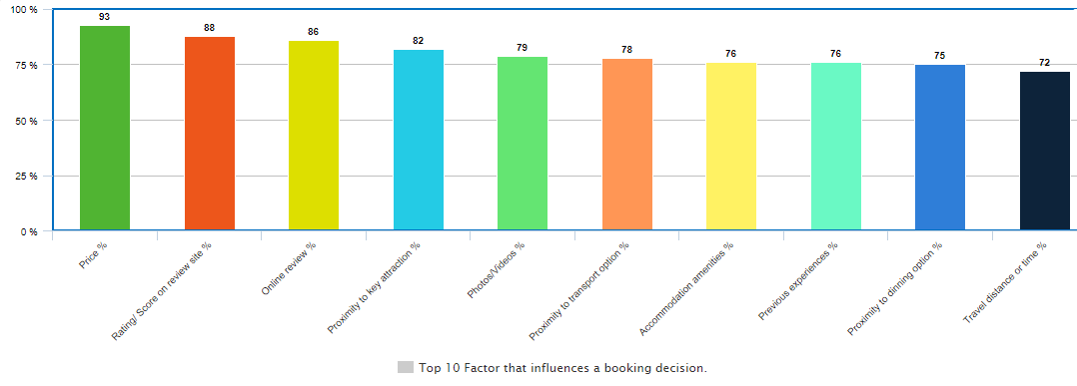

# Aims and objectives of study

## Aims

To learn and understand customer behavior while making online booking decision on the basis of different influencing factor mentioned in the figure below:

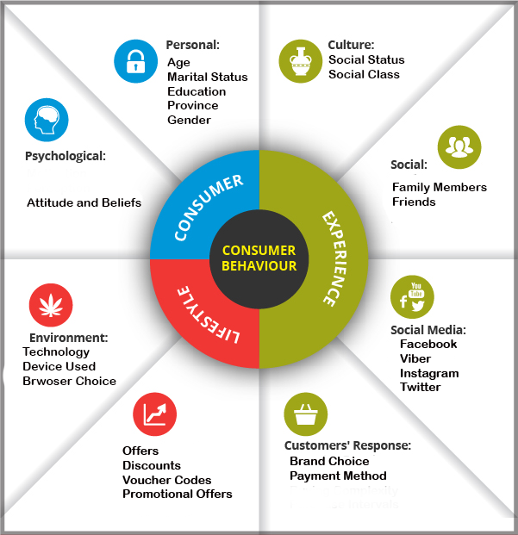

## Objectives

**Personal Objectives**

* Learn about the hotel industry and Online Travel Agents (OTA) and understand how they are running business online.
* Understand the customer behavior while making online booking decision.
* Learn about the factors that influence customer decision while making online booking.
* Collect data from interviews, survey and measure the effect on decision making on the basis of age, gender, residence.
* Study different books, website, journals, past research paper and implement the knowledge gained for doing research.
* Perform citation for content from other sources used in research paper and provide credit to original source.

**Academic Objectives**

* Completion of research providing proper finding and solution for the problem.
* Complete the research within the estimated time.
* Prepare the standard document for the research.
* Completion of bachelor degree with good marks.

**Technical Objectives**

* Learn to use different tools and technology.
* Learn about the data visualization tool and understand the customer behavior through visualization.

# Research Questions

* Does price of hotel have effect on hotel booking decision?
* Does payment system have effect on booking decision?
* Do online reviews have effect on booking decision?
* Does rating of hotel have effect on booking decision?
* Do recommendation from friend or relatives effect booking decision?
* Does photos or videos of hotel and room have effect on booking decision?

# Ethical Considerations

The research in any topic must consider ethical issues seriously. Ethical consideration is one of the most important part of any research and the research can be invalid or complete failure without this part. When data and information are collected from customer or different source, then ethical issues arise. I have also collected data from different source, surveys and interviews but I have considered all ethical issues while doing research. So, my research is ethical. Some of the ethical consideration are:

* Informed Consent

The participant in the research should be fully informed about the ongoing research. The participant should be made known of purpose of research, how finding of the research will be used, who can access the finding, impacts of participation. The participant can make decision whether they will be part of the research or not through this.

* Voluntary Participation

The participant in the research should be free from any force or threats. Participant should be free to stop their participation at any time without any negative on anything like their future involvement, relationship with other person. The participant is not required to give any explanation if they want to leave.

* Do not harm

The research could harm in both mental and physical form like giving pain, stress, privacy insecurity. The research should not harm any religion, people, society directly or indirectly. The researcher should make sure that no harms are made while doing research.

* Confidentiality

Confidentiality means the data and information should be protected. The personal information of customer and their data should be protected and archived. The personal information should not be published in any document or given access to outsource.

* Anonymity

Anonymity means the identity of participant should be unknown to researcher as well. It is stricter form of privacy.

* Intellectual Property

The researcher takes data and information from different source while doing research like website, journal, book, past research and that information should be cited and credit should be given to original source.

# Reference

*Hotel Industry; Everything You Need To Know About Hotels!* (2020) available from <https://www.revfine.com/hotel-industry/> [25 May 2020]